# New Innovations Workshops – June 2016

## Evaluations

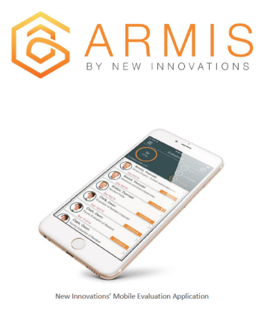School of Nursing Computer Classroom, K4007  
Thursday, June 2, 2016  
2:00 p.m. – 3:00 p.m.

* Evaluation Builder (Forms) & Optimizing for Mobile
* Session Manager
* Evaluation Reports

RSVP to Laura prior to the workshop for a copy of the NI Handbooks.

*Unable to attend? Watch Webinar 8.26 [56 minutes] for an overview of the new Evaluation Form Builder and recent updates to Evaluation Reports.*

## Preparing for the New Academic Year

School of Nursing Computer Classroom, K4007  
Thursday, June 9, 2016  
2:00 p.m. – 3:00 p.m.

* Onboarding Incoming Residents and Fellows
* Block Schedules
* Evaluations

RSVP to Laura prior to the workshop for a copy of the NI Handbook.

*Unable to attend? Watch Webinar 18.01 [55 minutes] for an overview of preparing the software for the new academic year.*

## Open Lab Time

School of Nursing Computer Classroom, K4007  
Thursday, June 16, 2016  
2:00 p.m. – 4:00 p.m.

Laura will be available for questions and support as coordinators work on program specific tasks.   
No RSVP necessary and you are not obligated to stay the entire time.